**Common Intents**

1. **Load a web URL**

An Android application allows users to open a web browser with its URL. This is the syntax that we need to apply this intent.

In the file AndroidManifest.xml, we also need to declare the following intent filter.

To implement this activity as an application on Android Studio, we need to implement an edit text and a button. The edit text is used to get the URL of the web browser from users. The button is used to trigger the activity of getting data from the edit text and open the web page with that URL.

1. **Maps: show a location on a map**

An Android application allows users to input a location in the form of (latitude, longitude) or name. Then, the application will show that location on the map in the map application on the phone. This is the syntax that we need to apply to that activity.

In the file AndroidManifest.xml, we also need to declare the following intent filter.

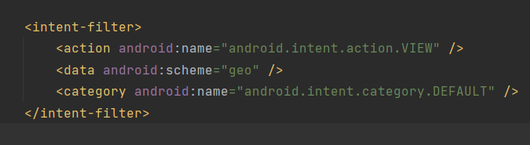

To implement the activity as an application in Android Studio, we can choose whether user want to input the name of locations or the latitude and longitude of them. In both cases, we need to convert the information that users input into a form that is suitable for the intent.





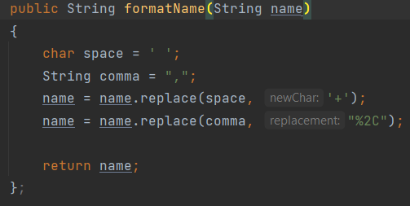

We allow users to choose the mode of information that they want to input. Then, they can input the location information and press “Locate” button to find the location.

1. **Play a media file**

An Android application allows users to play a media file with the input artists, genres, titles, playlists, albums information of the song. This is the syntax that we need to run the application to play a song with all these attributes.

In the file AndroidManifest.xml, we also need to declare the following intent filter.

To implement the activity, we need to have 5 edit texts to get the information from the user and a button to trigger the play activity.

In this case, since there is no music media file available in the mobile app, the application just move to the music playing application.